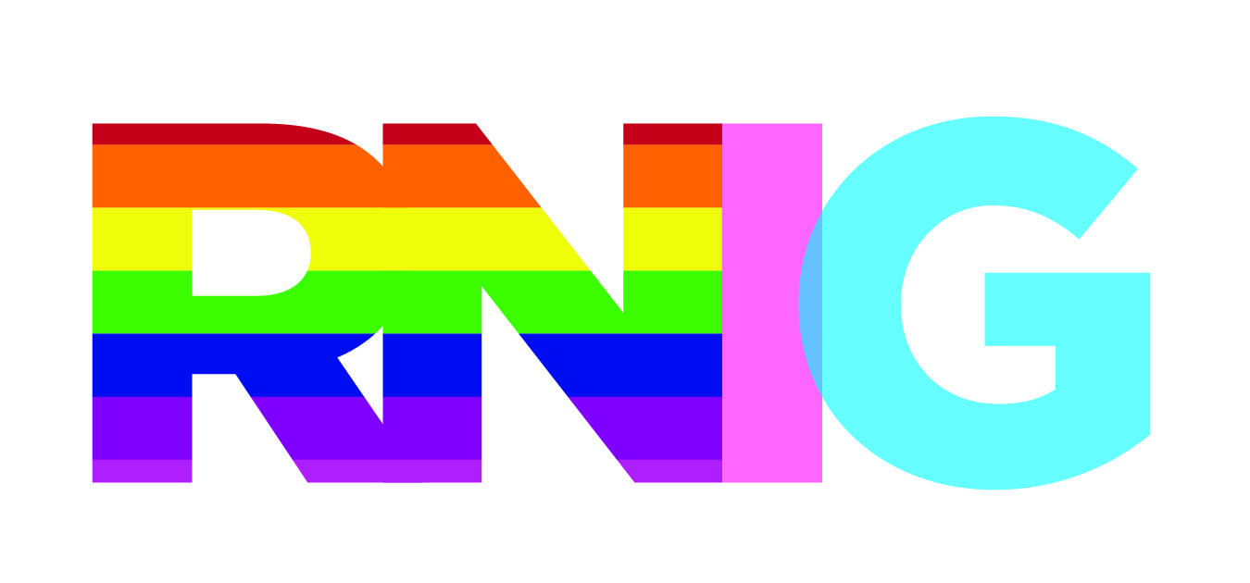
Rainbow Nursing Interest Group
An Interest Group of the Registered Nurses Association of Ontario (RNAO)
http://rnig.weebly.com/

Creating a Welcoming and Inclusive Environment for LGBTQ People

- provide LGBTQ cultural training for all staff, updated regularly
- don’t assume anything about an individual/family
- if you are unsure, and need to know, ask politely
- use neutral language – partner, spouse, partnered, parent – verbal and written
- verbally, use preferred name and pronoun, if different from health card
- ensure posters and literature portray LGBTQ people and issues
- use a positive space symbol only when requirements have been met:
  - providing a welcoming and inclusive atmosphere for people of all sexual orientations and gender identities
  - providing referrals to community resources for issues pertaining to sexual orientation and gender identity
  - advocating for youth, parents, employees and community members on matters related to gender identity and sexual orientation
  - ensuring all staff are LGBTQ culturally competent
- provide gender neutral bathrooms
- develop anti-discrimination, anti-harassment and diversity policies that include sexual orientation and gender identity and expression
  - use gender neutral language – employee, client, community member, person
  - include process to follow when policies not adhered to
  - post where highly visible for clients and staff
- develop a referral list for LGBTQ issues/resources
- add same sex and gender diversity imagery to education and marketing materials
- support and be visible at LGBTQ events
- celebrate/recognize LGBTQ awareness days

References:
National LGBT Health Education Center, The Fenway Institute: lgbthealtheducation@fenwayhealth.org

Ontario Public Health Association: A Positive space is a Healthy Place. 2007, updated 2011.

