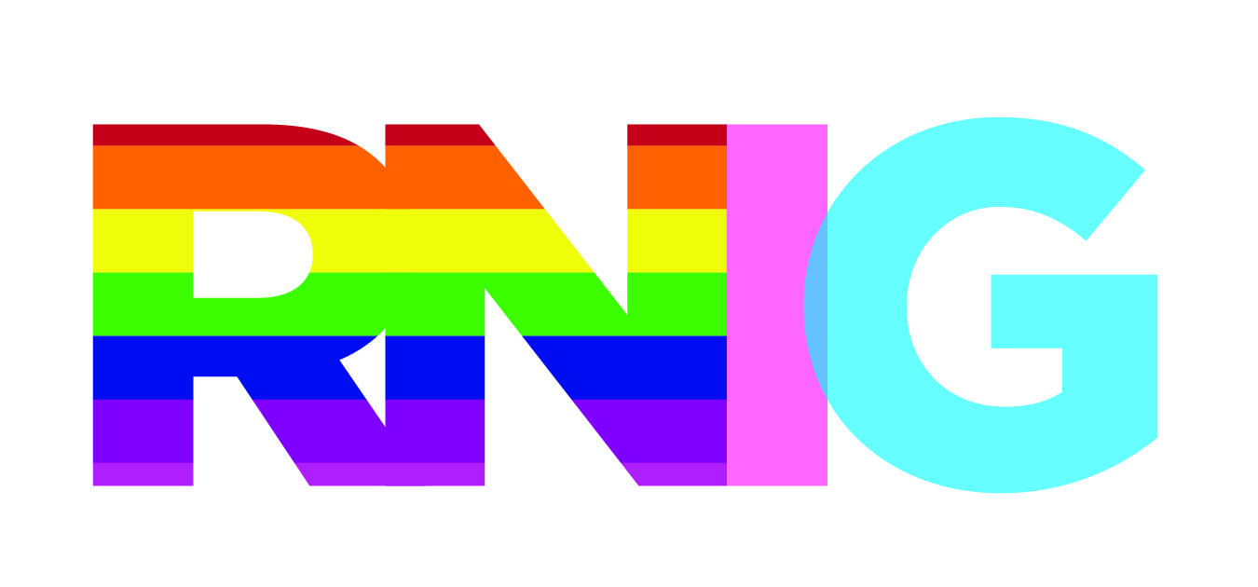
Rainbow Nursing Interest Group
An Interest Group of the Registered Nurses Association of Ontario (RNAO)
http://rnig.weebly.com/

Trans Definitions

Please note that these terms were created by the Ryerson Student Union Trans Collective and may not be generalizable to other communities. Each community has their own understandings of these terms. If you think a term or definition needs to be added or edited, email us at transcollective@rsuonline.ca
All-Gender Bathroom: An all-gender bathroom is a bathroom where anyone, regardless of gender, can access the space.
Single-Gender Bathroom: A single-gender bathroom is a bathroom which is either male or female, making it exclusive to one gender.
Transgender: Often referred to as simply ‘Trans’ (sometimes as ‘Trans*’), a transgender person is someone whose gender identity is different than the sex they were assigned at birth. For example, a transgender woman is a woman who was assigned male at birth but now identifies as a woman. Please note, being transgender is not the same as being gay. A transgender person can be heterosexual, bisexual, homosexual, asexual, or anything else!
Cisgender: Often referred to as simply ‘Cis’, a cisgender person is someone whose gender identity is the same as their assigned sex at birth. For example, a cisgender woman is a woman who was assigned female at birth and now identifies as a woman.
Non-Binary: A non-binary person is someone whose gender identity is neither male nor female, or a mix of the two. For example, a non-binary person might have been assigned male at birth but now identifies as genderqueer.
The Gender Binary: The gender binary refers to the belief of only two genders, male and female, which are normally considered opposite. Some people are comfortable fitting into this binary, other people are not. It is important to note that cisgender and transgender people can identify within the binary.
Gender Identity: A person’s gender identity is how that person identifies their gender. Gender identity is something that can be personal, or even private. Do your best not to assume people’s gender identity.
Gender Presentation: A person’s gender presentation is how that person chooses to express their gender. Gender can be expressed in so many ways! Do your best not to assume someone’s gender identity on the basis of their presentation – remember, everyone has their own unique way of presenting and identifying their gender.
Pronouns: Some examples of pronouns are “He”, “She” or “They”. In English, we normally use pronouns to substitute for a noun, for example: ‘That is Jenny’s bike’ becomes ‘That is her bike’. Some transgender people use “he” or “she”, but others use “they”, “ze”, or others! One way to show your support for transgender people is to ask people’s pronouns before assuming, and to respect people’s pronoun preferences.
Trans*: Sometimes people may use the word Trans* (with the asterisk) to refer to all non-cisgender people. The addition of this asterisk is used to note that there are non-cisgender people who may not identify as transgender. Please note that this is a controversial term and should be considered carefully before being used.
Cisgender Privilege: Cisgender privilege refers to the power and privilege held by cisgender people. This is not to imply that cisgender people have it ‘easy’, just that they don’t face the unique difficulties experienced by transgender people.
Cissexism: Cissexism is the domination of cisgender people, along with the oppression and erasure of transgender people. One example is the predominance of only male and female bathrooms in most spaces, despite the fact that these bathrooms make many transgender people feel unsafe. Cissexism can be recognized in media, in classrooms, and so many other places! Cissexism can be difficult to recognize if it’s not hurting you, try to listen to the transgender people in your life when they mention it or share examples.
Transphobia: Transphobia is fear and/or violence towards transgender people, based on their gender identity and/or gender presentation. (Remember: not all violence is physical!)
Transmisogyny: Transmisogyny refers to the unique experiences of fear and/or violence towards transgender women and other trans-feminine people. Transmisogyny combines sexism/misogyny with cissexism/transphobia.
Binarism: A specific form of thought, connected to imperialism, colonialism, and white supremacy, which frames topics as binary and oppositional (good/bad, male/female, white/black). This has been used as a tool to oppress those who do not fit into this binary, specifically colonized and racialized people who do not fit into the white, imperialist, and colonial categories of male and female.
Non-Binary Erasure: Non-binary erasure refers to the erasure and oppression of non-binary people. This can include overt violebnce or more subtle forms, such as the lack of recognition of non-binary people or the refusal to use a non-binary person’s preferred pronouns.

